horizontal line

**Delhi Technological University**

Department of Applied Physics

IVth Semester

**MICROPROCESSORS & INTERFACING**

**MPI EP - 206**

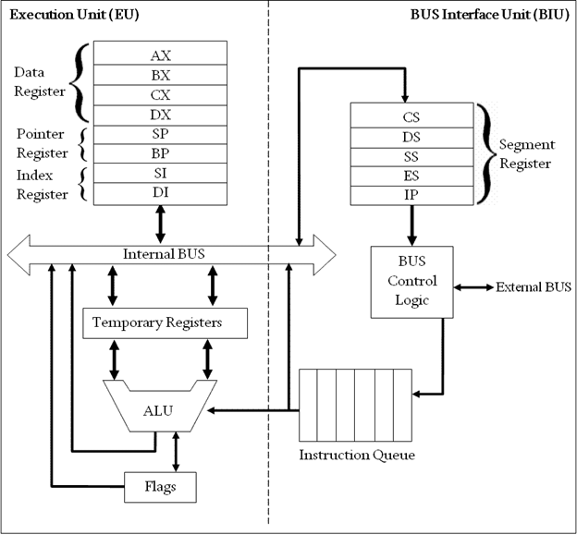

# **Submitted by :**

**ADITYA SINGH, 2K19/EP/005**

**Submitted to:**

**Dr. Rishu Chaujar**

# **Experiment 9**

**Find the Factorial of an 8-bit Number.**

**THEORY**

1. The number whose factorial is to be computed is stored in the CX register.
2. Store 1 in AX register and 0 in DX register.
3. fact : (Loop)
4. Multiply the contents of AX and CX register and store them in DX:AX pair of registers. *mul CX* is used to execute this instruction. The higher part of the product is stored in the DX register and lower part in the AX register.
5. Repeat step 4 until CX=0
6. Copy the contents of DX and AX in a different memory location.

**CODE**

**mov si, 2000h**

**mov cx, [si]**

**mov ax, 1**

**mov dx, 0**

**fact:**

**mul cx**

**loop fact**

**mov si, 2010h**

**mov [si], dh**

**mov [si+1], dl**

**mov [si+2], ah**

**mov [si+3], al**

**hlt**

**OUTPUT**

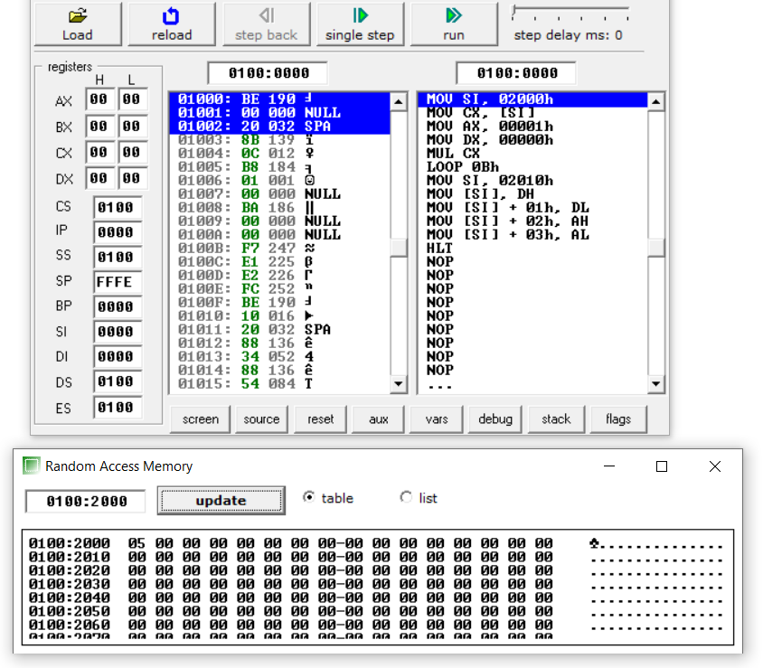

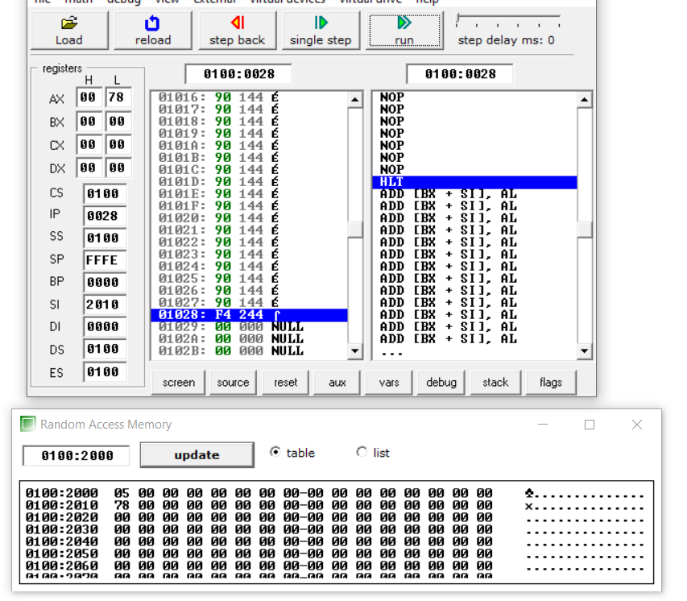

**END**